**Language Translator**

**Problem Recognition**

We live in world full of different languages and where there is need to communicate and learn new languages.Language barrier can make people not to understand each other and can slow down communication between two or more parties.

**Problem Solution**

To overcome the challenge of language barrier in written documents we have come up with Language Translator ,which is able to convert written language documents from one Language to the desired Language.The Language Translator Software first reads the translated written document for you then displays the translated written text on your screen.

Language Translator software can also be used to learn new Languages by emulating Language Tutor.

### Planning and Requirement Analysis

To Write Language Translator Software ,we use Python as our programming Language of choice .

Download python from there official website, python.org.

In our case we are using python version 3.6.8.In your case you can use the latest version which is version 3.9.6.Then use pip to install the following modules .My text editor is visual studio code.

pip install  PyQt5

pip install  textblob

Pip install pyttsx3

### Building or Developing the Product

from PyQt5.QtWidgets  import *

from  textblob import  TextBlob

import os

import sys

import pyttsx3

reader = pyttsx3.init()

class MainWindow(QWidget):

    def __init__(self):

        QWidget.__init__(self)

        self.the_language_chosen=""

        self.final_text_file=""

        self.setWindowTitle("Translate from one Language to another :")

        grid_layout=QGridLayout()

        self.path_to_file=QLineEdit()

        self.path_to_file.setPlaceholderText("file_name.txt ")

        label=QLabel("Choose the Language that you want to translate to :")

        grid_layout.addWidget(self.path_to_file,10,13)

        grid_layout.addWidget(label,10,10)

        self.languages=QComboBox()

        self.languages.addItems(["English","French","Germany","Spanish","Chinese","Italian","Greek","Latin","Arabic","Kiswahili"])

        self.languages.currentIndexChanged.connect(self.choose_language)

        button=QPushButton("Translate To a new Language")

        button.setStyleSheet("color:yellow")

        button.setStyleSheet("background-color:blue;color:yellow;border-radius:30px;")

        button.clicked.connect(self.translate)

        self.textarea=QPlainTextEdit()

        self.textarea.setReadOnly(False)

        self.textarea.setMinimumWidth(560)

        self.textarea.setMinimumHeight(300)

        self.textarea.setWordWrapMode(True)

        grid_layout.addWidget(self.textarea,12,10)

        grid_layout.addWidget(button,12,12)

        grid_layout.addWidget(self.languages,10,12)

        self.setStyleSheet("Background-color:yellow;font-size:30px;")

        self.setLayout(grid_layout)

    def translate(self):

                 try:

                    file_dir=str(self.path_to_file.text())

                    text_file_to_be_translated=open(file_dir,"r")

                    text_file=text_file_to_be_translated.read()

                    final_text_file=TextBlob(text_file)

                    text_file_to_be_translated.close()

                    final_text_translation=final_text_file.translate(to=self.the_language_chosen)

                    self.textarea.insertPlainText(str(final_text_translation))

                    #you are about to read the translation.

                    reader.say(final_text_translation)

                    reader.runAndWait()

                 except OSError as e:

                     alert=QMessageBox()

                     alert.setWindowTitle("Kindly enter the path to the text to be translated and ensure you connect to the internet")

                     alert.setText(" Error: ,"+str(e))

                     alert.exec_()

    def choose_language(self):

            language_chosen=self.languages.currentText()

            if(language_chosen=="English"):

                self.the_language_chosen="en"

            elif(language_chosen=="French"):

                self.the_language_chosen="fr"

            elif(language_chosen=="Spanish"):

                self.the_language_chosen="es"

            elif(language_chosen=="Germany"):

                self.the_language_chosen="de"

            elif(language_chosen=="Chinese"):

                self.the_language_chosen="zh"

            elif(language_chosen=="Italian"):

                self.the_language_chosen="it"

            elif(language_chosen=="Greek"):

                self.the_language_chosen="el"

            elif(language_chosen=="Latin"):

                self.the_language_chosen="la"

            elif(language_chosen=="Arabic"):

                self.the_language_chosen="ar"

            elif(language_chosen=="Kiswahili"):

                self.the_language_chosen="sw"

app=QApplication(sys.argv)

mainwindow=MainWindow()

mainwindow.show()

app.exec_()

### Testing the Product

Before You run the python script you need to connect to the internet .When you run the python script you will get something like this .

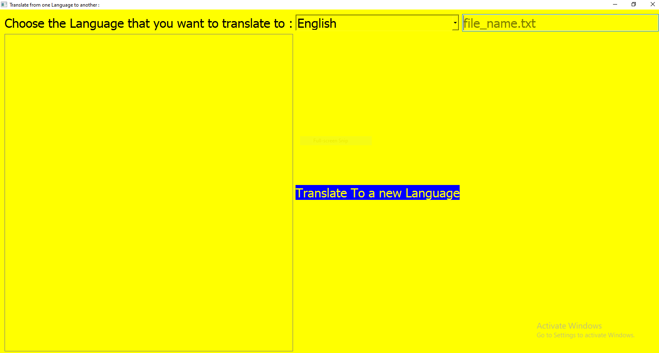

Enter the text file to be Translated to a different Language.

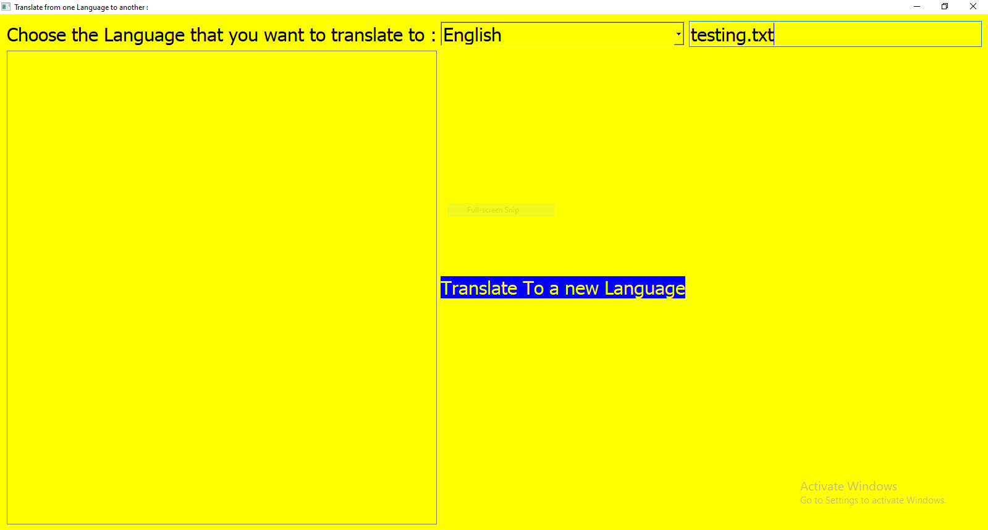

Testing.txt file looks like this :

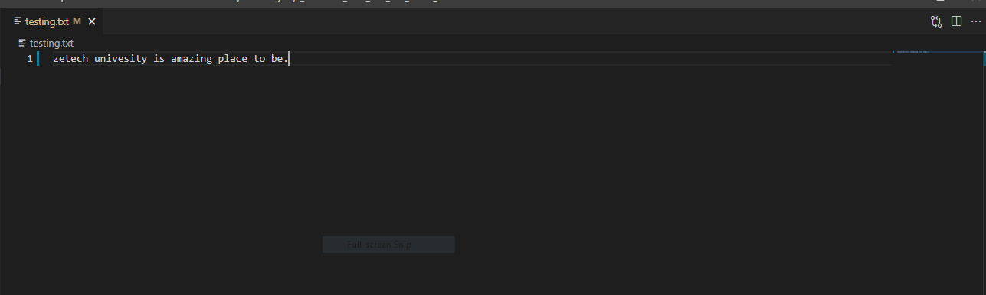

Choose the language to Translate on the combo box to then click on the button Translate to a new language.

